Installation procedure   
Method-1 🡪 with java jdk 8  
Method-2 🡪 open jfs

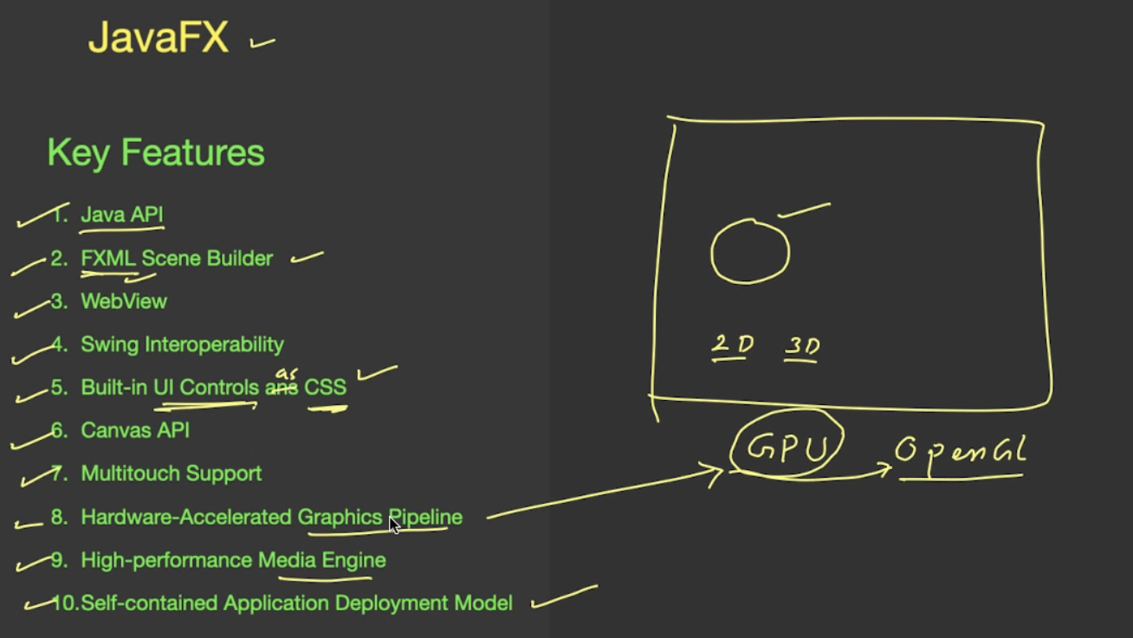

# **JAVA FX Application Structure**

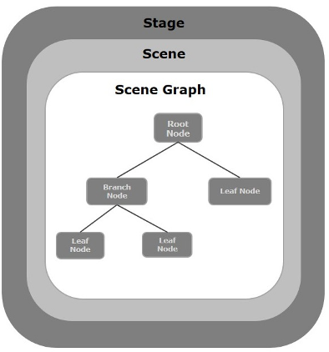

# **Java JFX Program structure**

# **Basic Java JFX Program Layout**

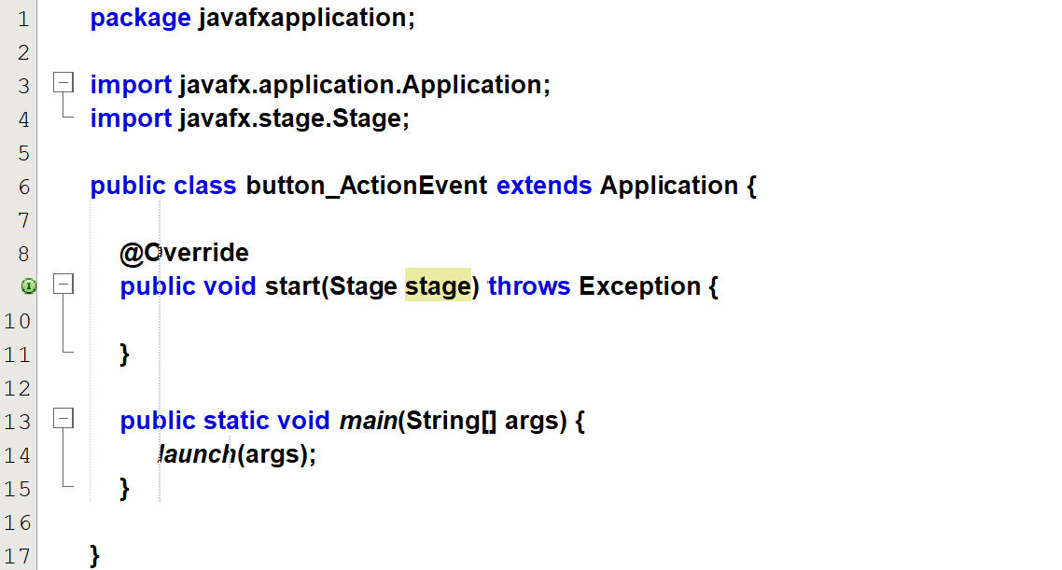

launch(args) will launch this application by calling the start method.

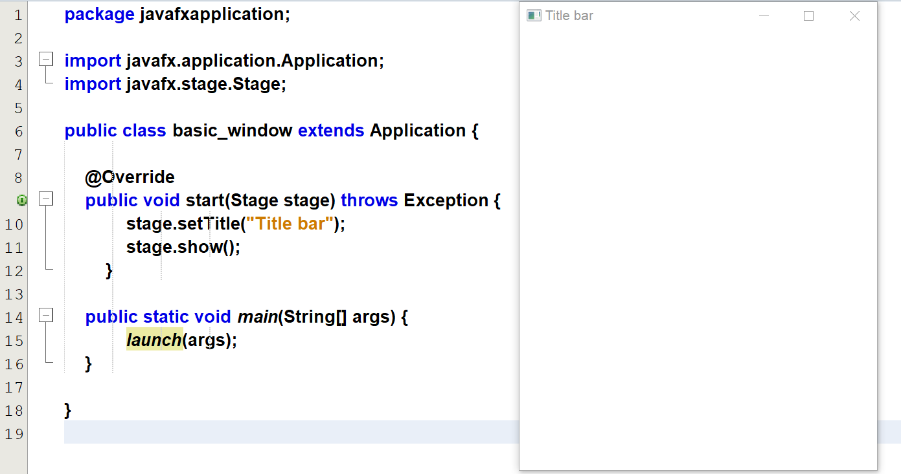

A stage can contains different scenes at different time.  
Scene will contain collections of graph called scene graph.

# **Structure of Java FX application**

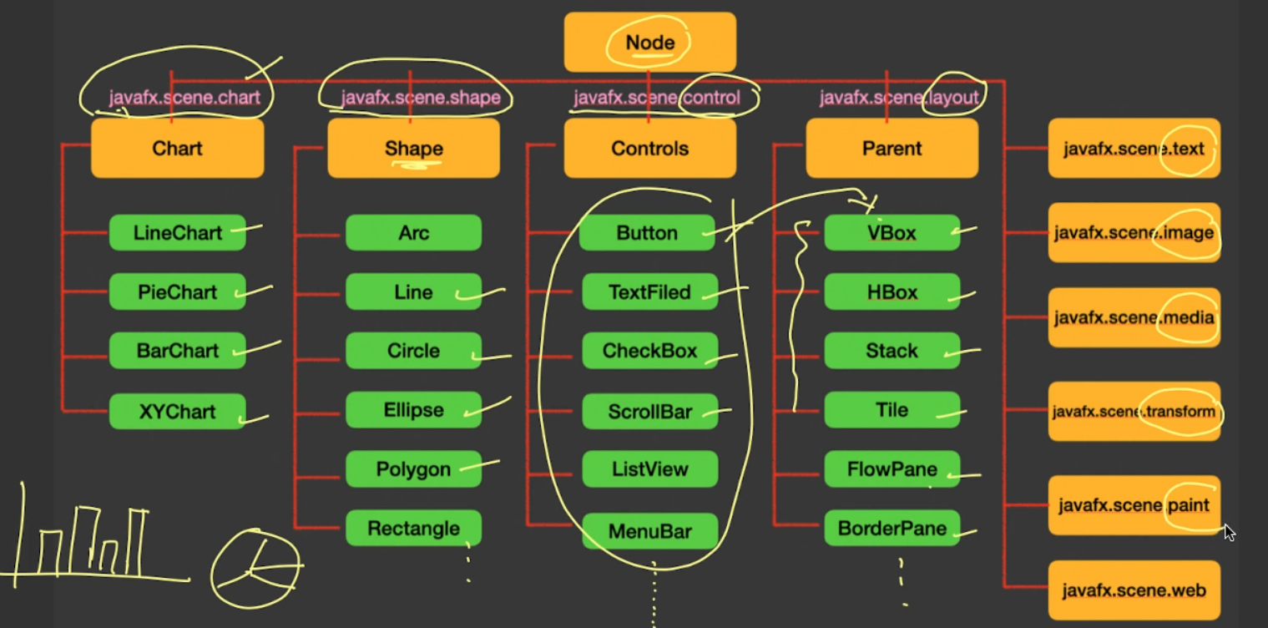

# **Structure of Java FX application**

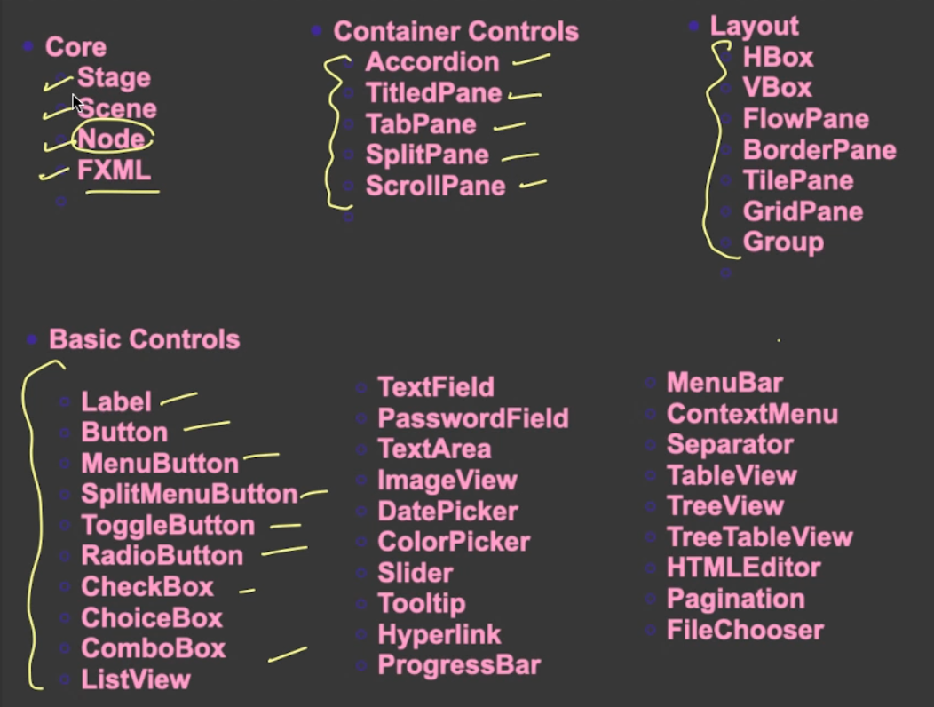

## **Refer button_ActionListener_method_1.java**

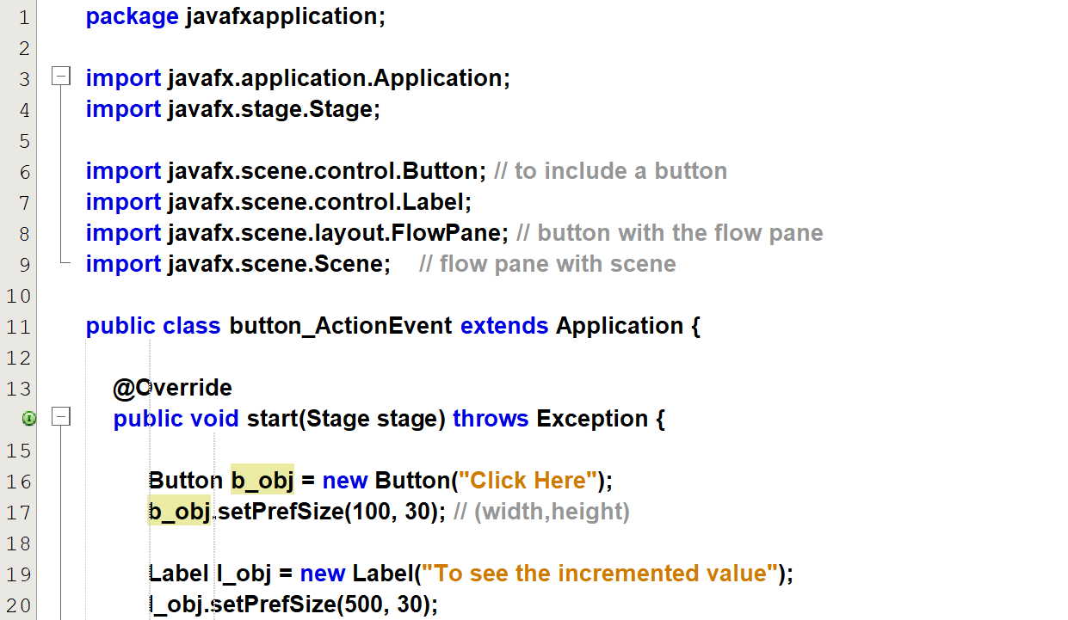  
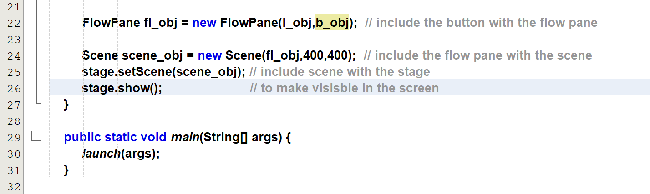

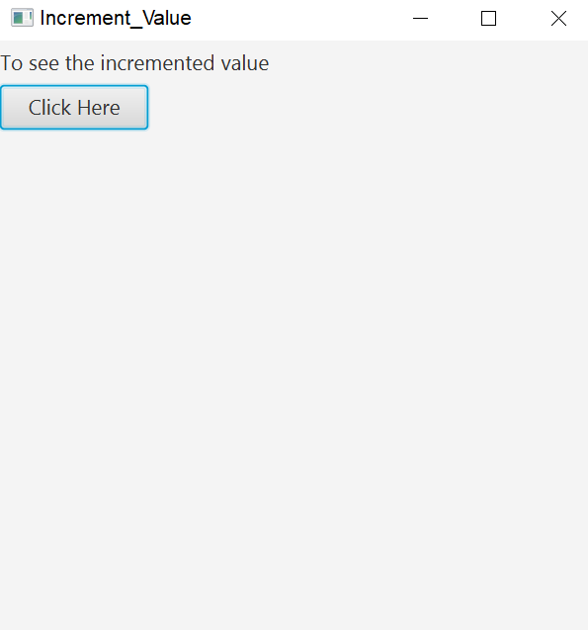

Implementing Event Handling

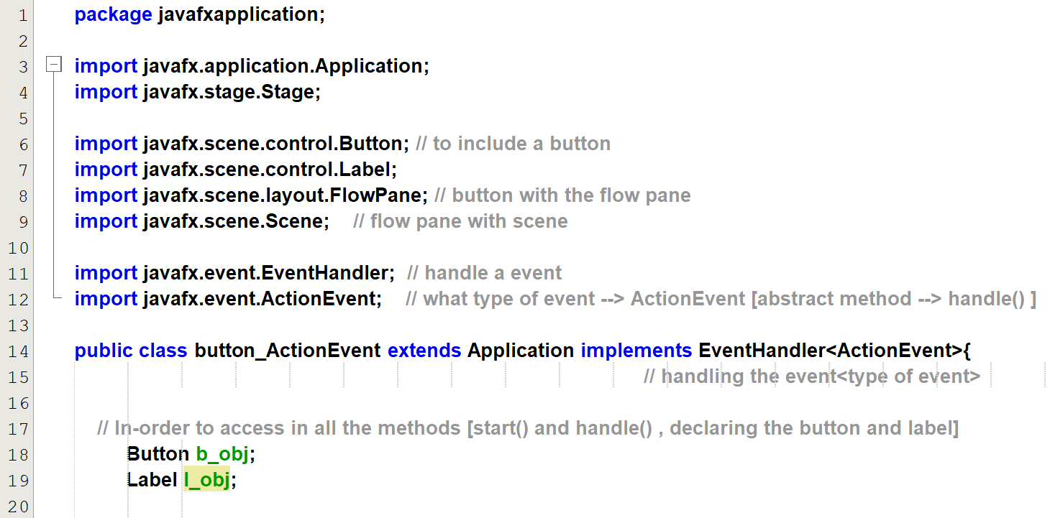  
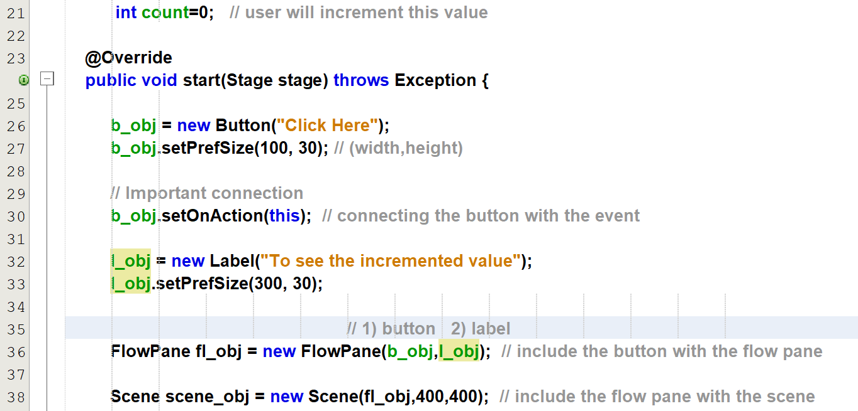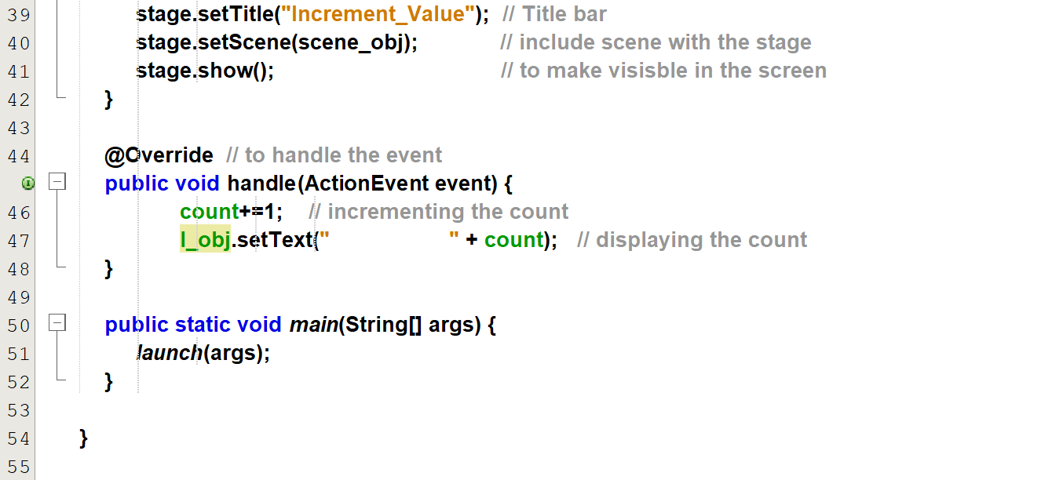

## **Refer button_ActionListener_method_2.java**

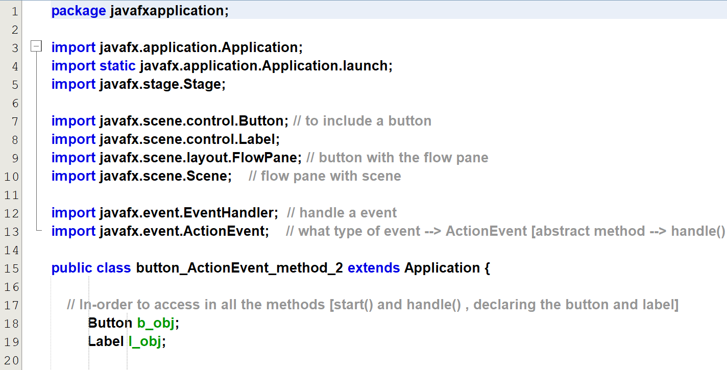  
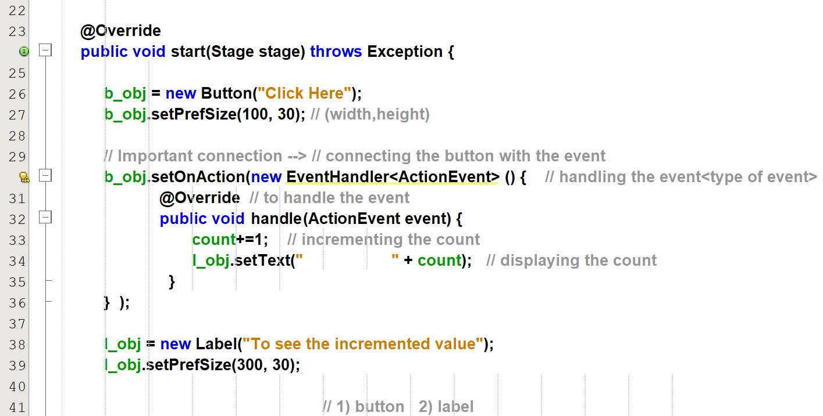  
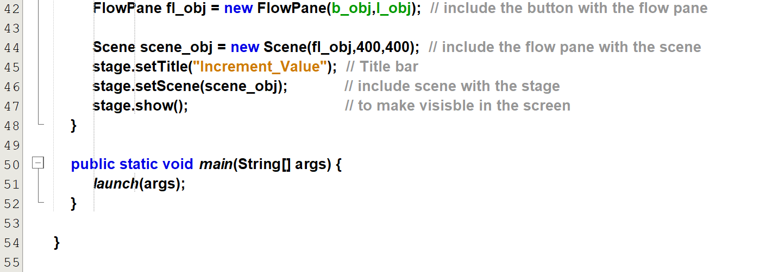

## **Refer button_ActionListener_method_3 [lambda expression].java**

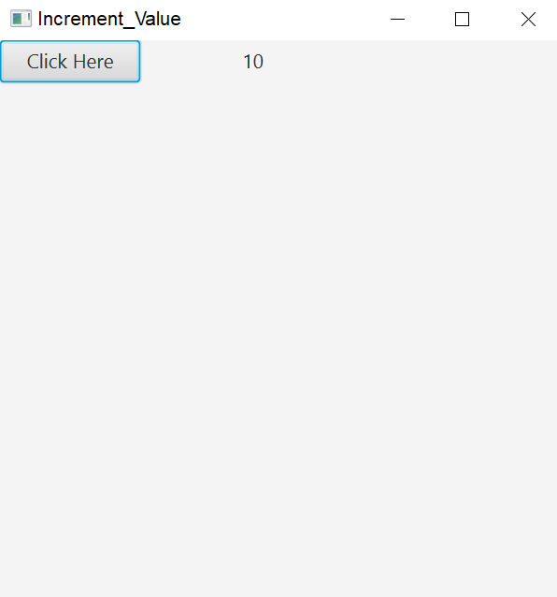

## **Refer checkbox_radiobutton_checkbox.java**

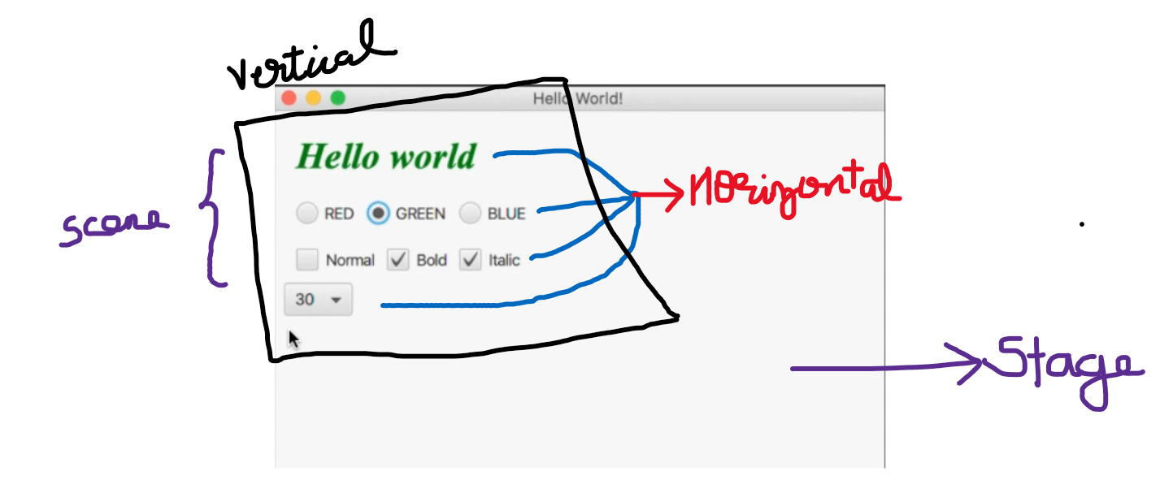

## **Refer textarea_slider**

TextArea.setPrefColumnCount(); 🡪 column size of the text area.  
TextArea.setPrefRowCount(); 🡪 row size of the text area.

Slider.setMajorTickUnits(5) 🡪 the entire window is divided into 5 segments.  
Slider.setshowTickMarks(true) 🡪 to display the tick units.

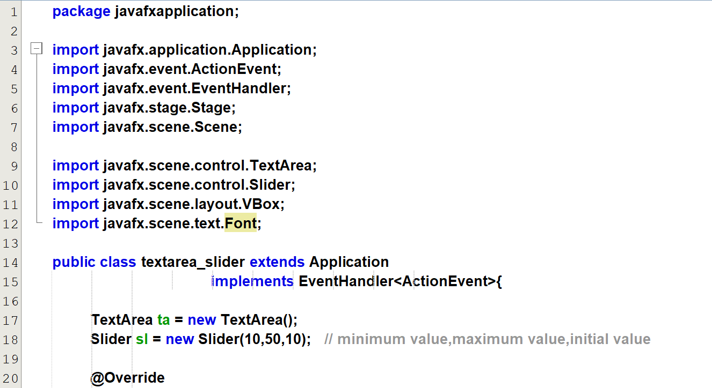  
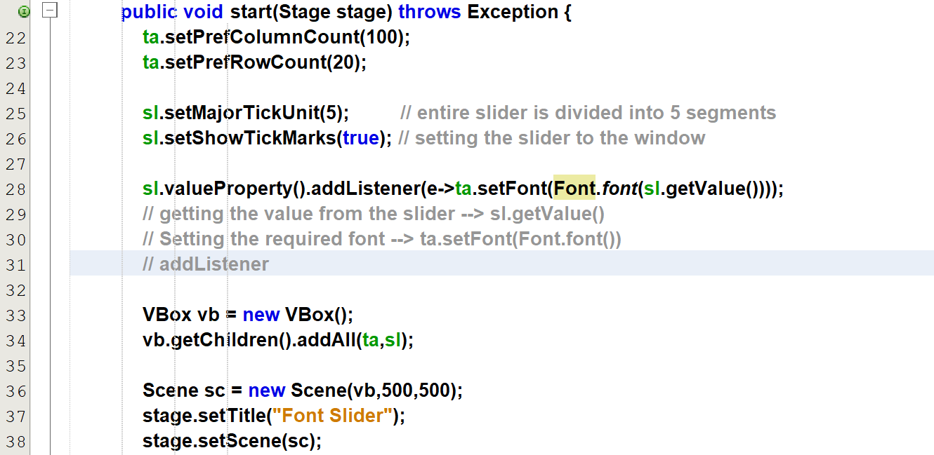  
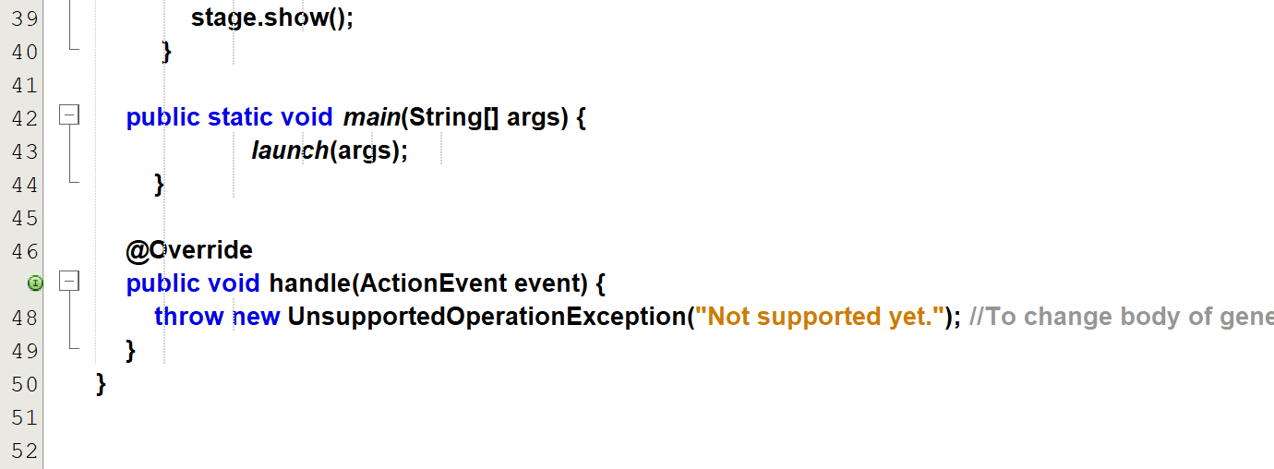

Output 🡪 [textarea_slider.mp4](output_clips/textarea_slider.mp4)

## **Refer datepicker_colorpicker_filechooser**

// shows the week number from the annual  
DatePicker.setShowWeekNumbers(true);